**OUTREACH SCHOOLS EXAMINATION BOARD**

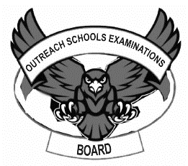**BEGINNING OF TERM III EXAMINATION 2023**

**BABY CLASS: (3 – 4 YEARS)**

**LEARNING AREA 2: LANGUAGE DEVELOPMENT I**

**My name is: ……………………………………………………………….**

**My School is: …………………………………….………………………..**

**I am in: ………………………………..…………………………….…………………..**

1. **Circle the odd man out.**

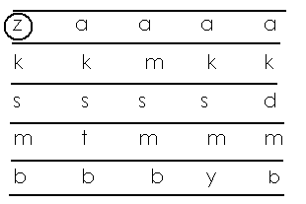

1. **Match and draw.**

  

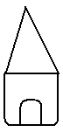 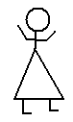__________

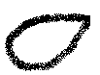 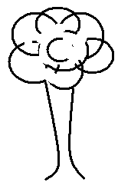___________

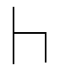 __________

 __________

 __________

  ___________

1. **Match letter to word.**

a cow

k man

p jug

j dog

d kite

c ant

m pot

1. **Copy the letters.**

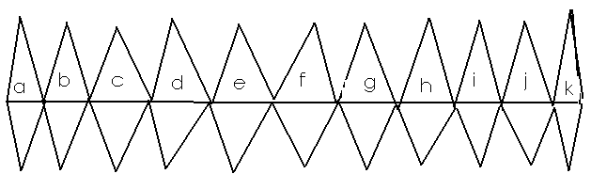

1. **Read and draw.**

|  |  |  |
| --- | --- | --- |
|  |  |  |
| cat | sun | tin |
|  |  |  |
| egg | hut | cup |

**End**